To start off with, I ran the server file first, and received this message on the console:

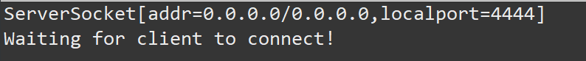

Afterward, I ran the client file which gave me the following prompt:



Upon entering the name, we are asked to put in the access code.

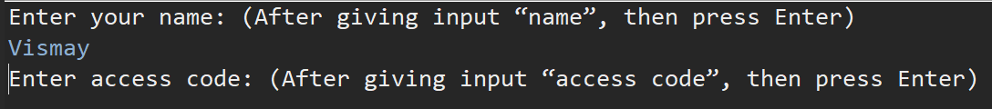

Upon receiving this prompt, I wanted to make sure the access code was working correctly so I purposely entered the wrong password and was met with this:

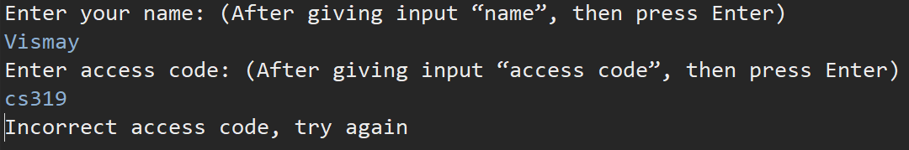

Following this, I put in the correct password which allowed me to send messages.

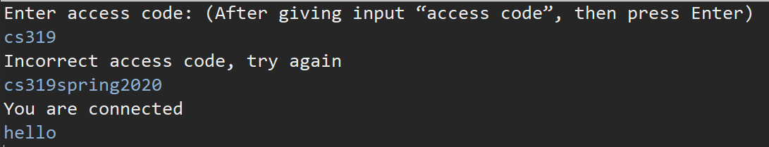

On checking the other window, we can see that the message successfully passed through the host to the server.

